



EMBEDDING INTEGRITY GUIDE
A guide to assist National Sporting Organisations and National Sporting Organisations for People with Disability to embed integrity across your sport.

JANUARY 2025

ACKNOWLEDGEMENT OF COUNTRY
In the spirit of reconciliation we acknowledge the Traditional Custodians of Country throughout Australia and their connections to land, sea and
community. We pay our respect to their Elders past, present and future and extend that respect to all Aboriginal and Torres Strait Islander peoples.

We recognise the outstanding contribution Aboriginal and Torres Strait Islander peoples make to sport in Australia and celebrate the power of sport to promote reconciliation and reduce inequality.

COPYRIGHT


Artwork by Chern’ee Sutton

The Commonwealth owns the copyright in all material produced by Sport Integrity Australia. This work by ©Commonwealth of Australia 2024 – Sport Integrity Australia is licensed under a
Creative Commons Attribution-NonCommercial-NoDerivatives 4.0 Unported License with the exception of:

- the Commonwealth Coat of Arms
- Sport Integrity Australia logo
- any protected names and symbols under Commonwealth legislation
- any registered trademarks owned by the Commonwealth of Australia
- photographs of staff and premises
- content supplied by third parties
- content otherwise labelled.

To the extent that copyright subsists in third-party quotations and diagrams, it remains with the original owner and permission may be required to reuse the material. Content from this publication should be attributed as: Sport Integrity Australia, Embedding Integrity Guide, January 2025.

The details of the relevant licence conditions are available on the Creative Commons website, as is the full legal code for the CC BY 4.0 AU license.

THIRD PARTY COPYRIGHT: Wherever a third party holds copyright in material presented in this publication, the copyright remains with that party. Their permission may be required to use the material.

Sport Integrity Australia has made all reasonable efforts to:

- clearly label material where the copyright is owned by a third party
- ensure that the copyright owner has consented to this material being presented in this publication.

CONTACT US
Enquiries about the licence and any use of this document can be sent to: Sport Partnerships
Sport Integrity Australia
PO Box 1744 FYSHWICK, ACT 2609 AUSTRALIA

Enquiries: 1300 027 232
Email sportpartnerships@sportintegrity.gov.au Website www.sportintegrity.gov.au

INTRODUCTION
Sport Integrity Australia is proud to launch the 2025 Embedding Integrity Guide. This guide follows the release of the Integrity Implementation Guide in 2024.
The 2025 Embedding Integrity Guide features 17 actions, which are divided into Priority One (10) and Priority Two categories (7).
Priority One action items are the key tasks and minimum requirements that must be completed.
Priority Two action items are additional steps you can take to further embed integrity across your sport.
There are also a number of discussion points to help inform and guide collaboration with your relevant organisations and how they can support embedding integrity in your sport.
Resources (fact sheets, website content, assessment tools etc) are provided to complement and assist with completing the action items in the 2025 Embedding Integrity Guide. Resources are available at the resources for sport hub (Microsoft SharePoint Datashare link).
Your Sport Partnerships Manager will be in regular contact throughout the embedding process to help you complete the action items outlined in this guide.
Thank you for your ongoing support. If you have any questions, please reach out to your Sport Partnerships Manager.

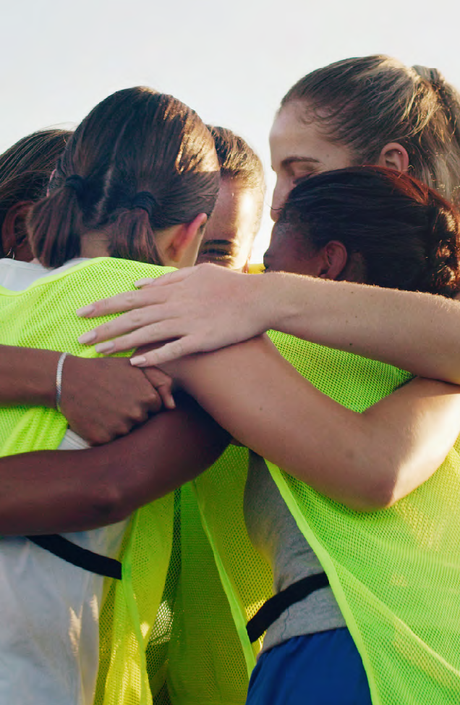


EMBEDDING INTEGRITY GUIDE
Policy and Governance

Priority Classification | Action no. | Key Actions | Completed? | Progress Comments
Priority 1 | 1 | Evaluate the implementation of your SIA-approved integrity education plan. | ☐Yes  ☐No  ☐Partial
Priority 1 | 2 | Work with relevant organisations (such as state bodies, affiliates, member organisations) to distribute SIA fact sheets to all levels of the sport, including the fact sheet that provides guidance on how to bind members to the sport’s SIA-approved NIF and anti-doping policies. | ☐Yes  ☐No  ☐Partial
Priority 1 | 3 | Update accreditation courses for coaches and officials to include explicit acknowledgement and acceptance of  SIA-approved NIF and anti-doping policies. | ☐Yes  ☐No  ☐Partial
Priority 1 | 4 | Update event registration forms to include explicit acknowledgement and acceptance of SIA-approved NIF and anti-doping policies. | ☐Yes  ☐No  ☐Partial
Priority 1 | 5 | Ensure measures are in place for confidential recording and storing of information relating to complaints, such as password protection. | ☒Yes  ☐No  ☐Partial
Priority 2 | 6 | Create a national integrity committee (or working group) with representatives from each state/territory that meets at least quarterly. | ☐Yes  ☐No  ☐Partial | N/A

Website

Priority Classification | Action no. | Key Actions | Completed? | Progress Comments
Priority 1 | 7 | Update your website to include links to SIA’s ‘make an integrity complaint/report’ and internal equivalent. | ☒Yes  ☐No  ☐Partial
Priority 1 | 8 | Remove old integrity policies from your website and replace with current NIF policies. Archive old integrity policies for reference and for historical matters. | ☒Yes  ☐No  ☐Partial
Priority 1 | 9 | Provide a link to SIA’s approved Anti-Doping Policy on your website. | ☒Yes  ☐No  ☐Partial
Priority 1 | 10 | Provide a link to the SIA app, the World Anti-Doping Agency’s prohibited list and SIA anti-doping education via SIA’s eLearning platform. | ☒Yes  ☐No  ☐Partial
Priority 2 | 11 | Include integrity in your website’s main navigation/menu, to assist members to find integrity related information. | ☒Yes  ☐No  ☐Partial

Communication

Priority Classification | Action no. | Key Actions | Completed? | Progress Comments
Priority 2 | 12 | Distribute SIA online forum/webinar invitations and links to recorded presentations (such as safeguarding and complaints) to relevant organisations. | ☒Yes  ☐No  ☐Partial
Priority 2 | 13 | Distribute links to SIA’s resources to relevant organisations.  - Investigation of Complaints Guidelines  - Case Categorisation and Guidance for Sanctions Booklet  - Standards And Prohibited Conduct Guide  - Bullying In Sport Guide | ☐Yes  ☐No  ☐Partial | N/A

Awareness and Education
SIA459-1224-B-1

Priority Classification | Action no. | Key Actions | Completed? | Progress Comments
Priority 1 | 14 | Complete the SIA Safeguarding self-assessment on the Australian Sport Commission’s online platform, Game Plan. | ☒Yes  ☐No  ☐Partial
Priority 2 | 15 | Ensure all relevant organisations are provided with information about their education requirements in the sport as outlined in the SIA approved NSO/NSOD integrity Education Plan. | ☒Yes  ☐No  ☐Partial
Priority 2 | 16 | Provide integrity-related materials (including posters, fact sheets etc) to SSOs to further distribute to relevant organisations. | ☐Yes  ☐No  ☐Partial | N/A
Priority 2 | 17 | Work with SIA to build and support the sport’s Member Protection Information Officer (MPIO) network. | ☐Yes  ☐No  ☐Partial | N/A

Key tasks for actioning in collaboration with SSO (or equivalent)

Priority Classification | Action no. | Key Actions | Completed? | Progress Comments
Discussion | 1 | SSOs should have procedures in place for confidential recording and storing of information relating to complaints. | ☐Yes  ☐No  ☐Partial | N/A
Discussion | 2 | SSOs should remove old policies from website, and link to NSO/NSOD integrity page. | ☐Yes  ☐No  ☐Partial | N/A
Discussion | 3 | SSOs should establish an integrity contact. | ☐Yes  ☐No  ☐Partial | N/A
Discussion | 4 | SSOs integrity contacts should complete the MPIO training course. | ☐Yes  ☐No  ☐Partial | N/A
Discussion | 5 | SSOs should provide to the NSO/NSOD copies of their board/ committee resolutions to endorse the NIF policies. | ☐Yes  ☐No  ☐Partial | N/A
Discussion | 6 | SIA and/or NSO/NSOD should present to SSO executive and board on the NIF and complaints processes. | ☐Yes  ☐No  ☐Partial | N/A
Discussion | 7 | SSOs should support local clubs and associations to complete the above tasks at their level. | ☐Yes  ☐No  ☐Partial | N/A

